

**Birla Vishvakarma Mahavidyalaya**

**Engineering Collage (An Autonomous Institution)**

**Vallabh Vidyanagar - 388 120**

**Affiliated to Gujarat Technological University**

**A.Y. 2023**

# Assignment : II

**Course Title:** Digital System Design

**Name:** Akshay Singh

**Id no:** 21EL083

**Batch:** A11

**Course Code:** 3EL42

**Q.1) Design 4-bit Ripple Carry Adder with the help of 1-bit adder.**

**CODE:**

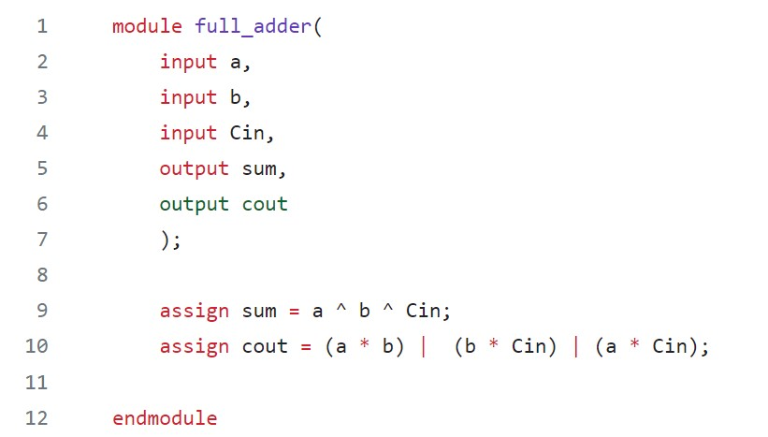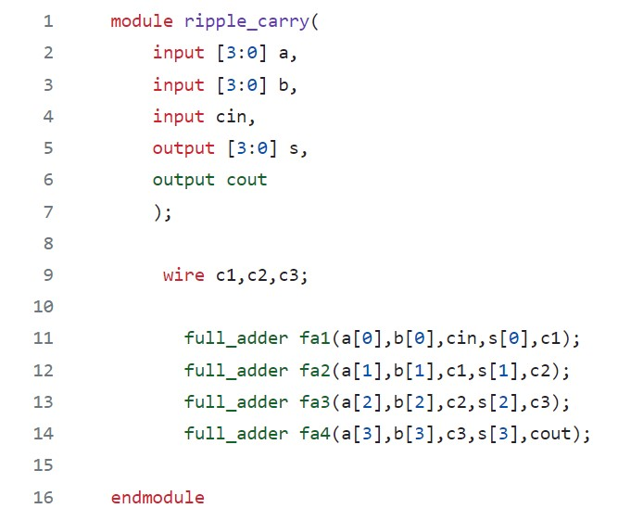

**TESTBENCH:**

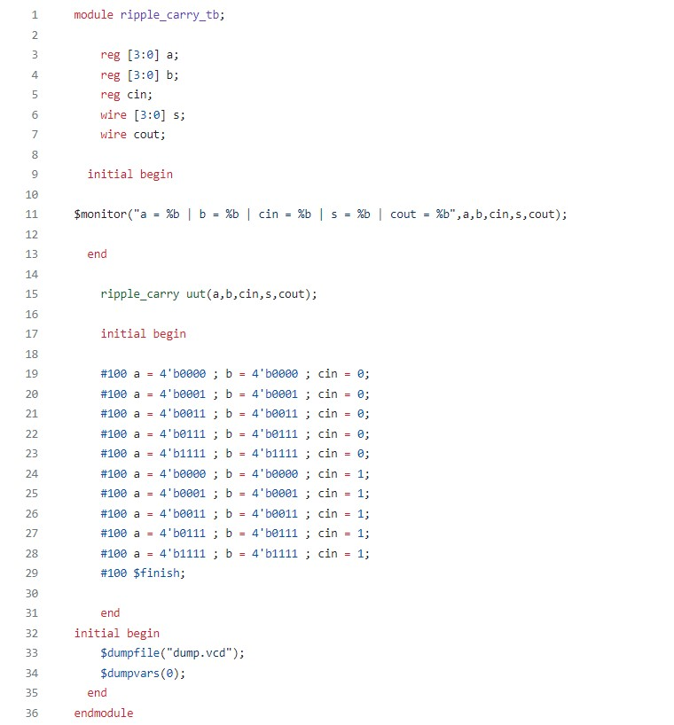

**OUTPUT:**

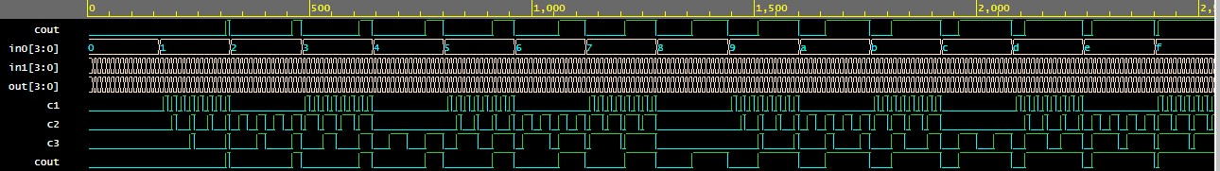

**Q.2) Design a D-flip flopand reuse it to implement 4-bit Johnson Counter.**

**CODE:**

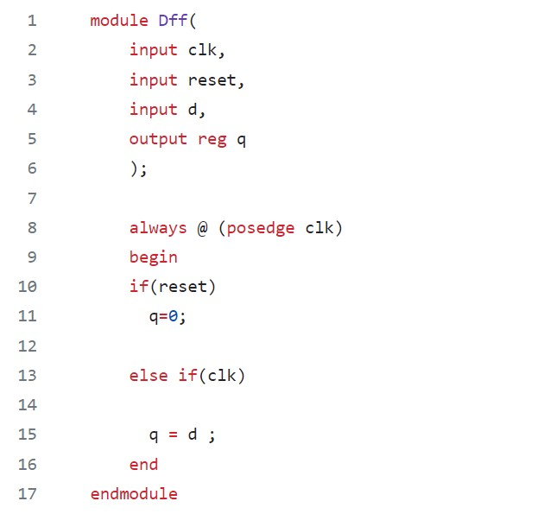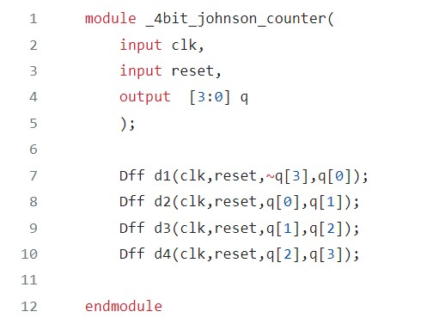

**TESTBENCH:**

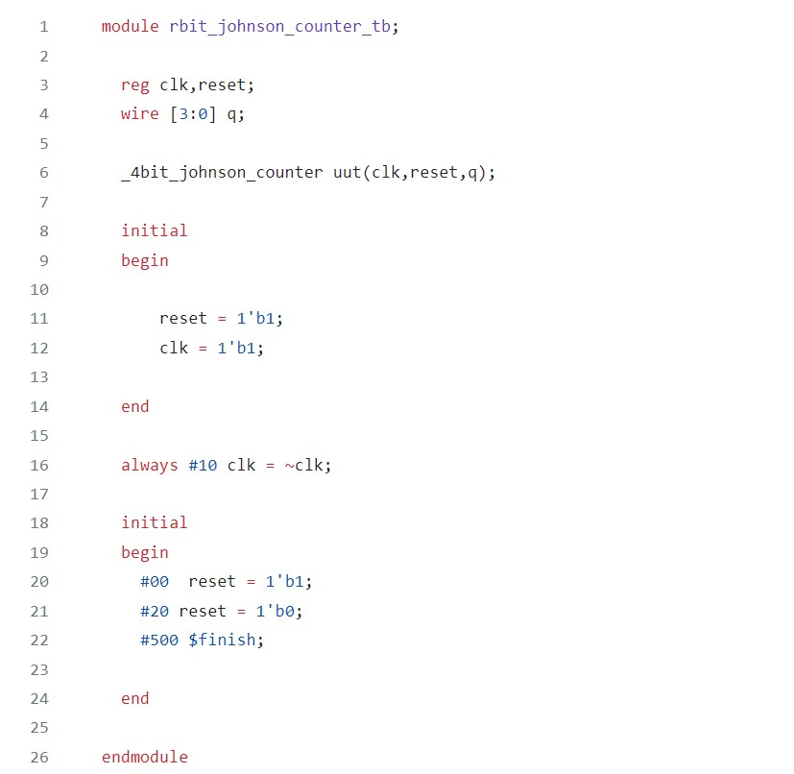

**OUTPUT:**

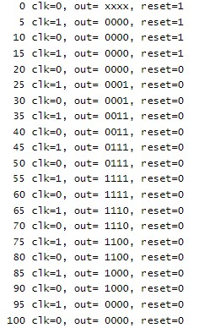

**Q.3) Reuse 2:1 Mux code to implement 8:1 Mux.**

**CODE:**

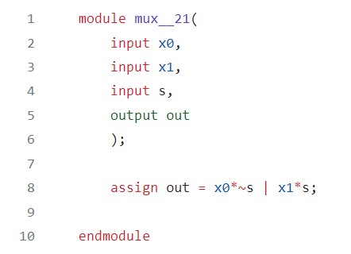

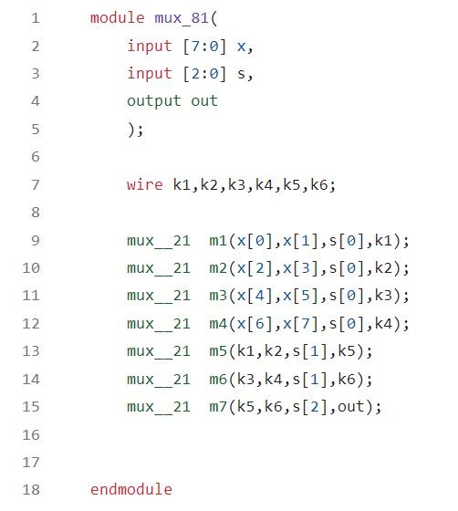

**TESTBENCH:**

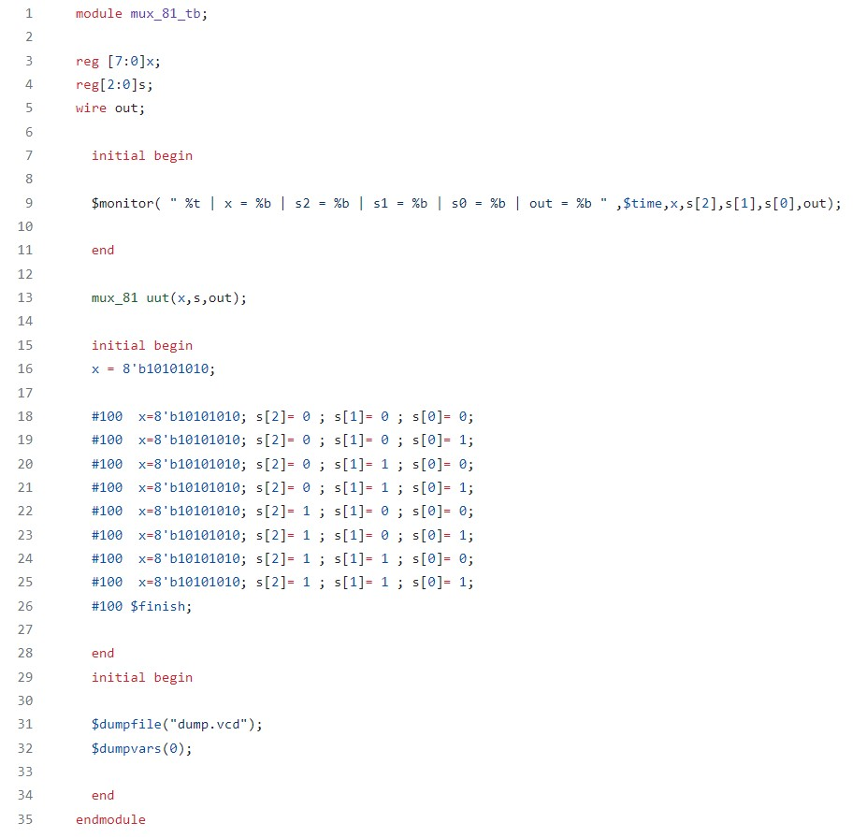

**OUTPUT:**

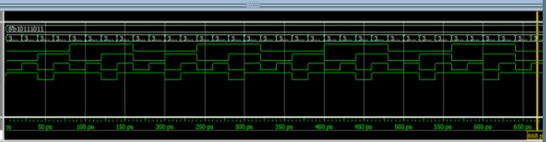

**Q.4) Design a Full Substractor with Gate Level Modelling style.**

**CODE:**

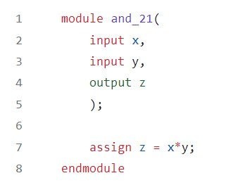

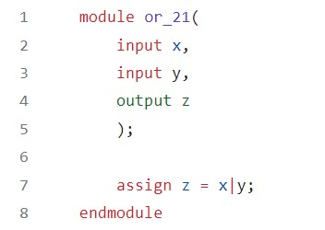

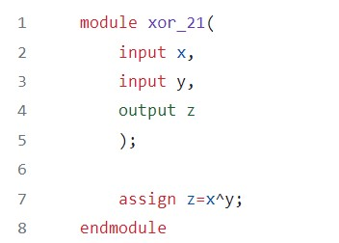

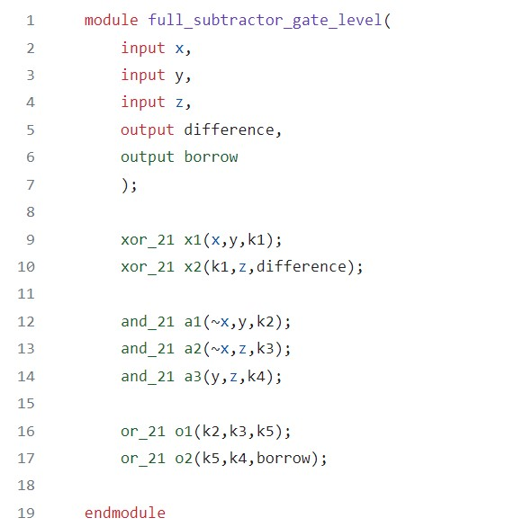

**TESTBENCH:**

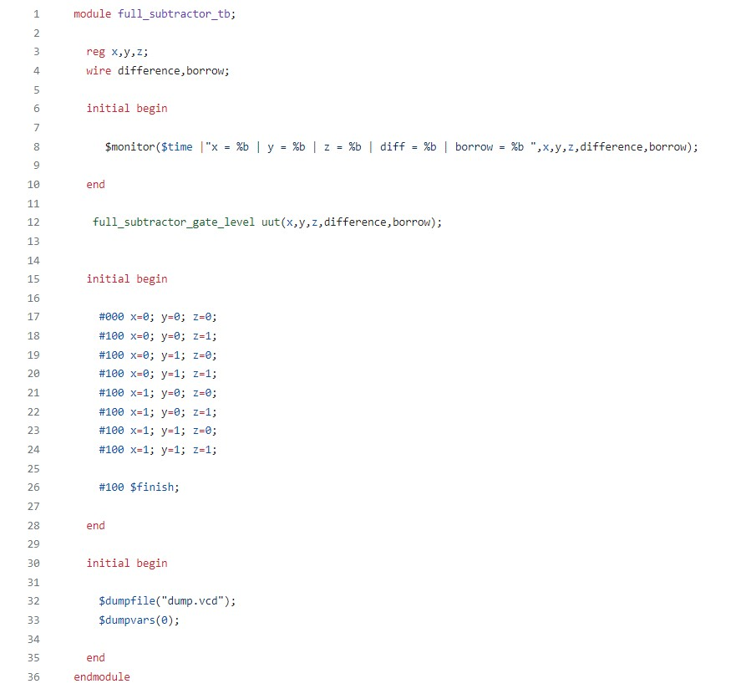

**OUTPUT:**

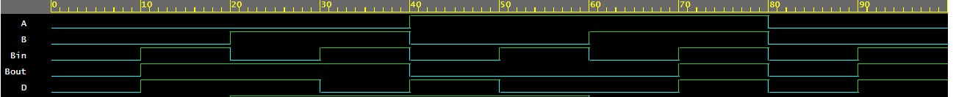

**Q.5) Design a 2 x 4 Decoder using gate level modelling.**

**CODE:**

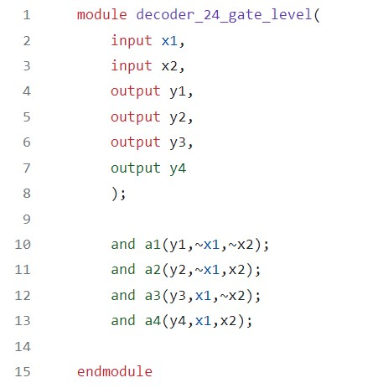

**TESTBENCH:**

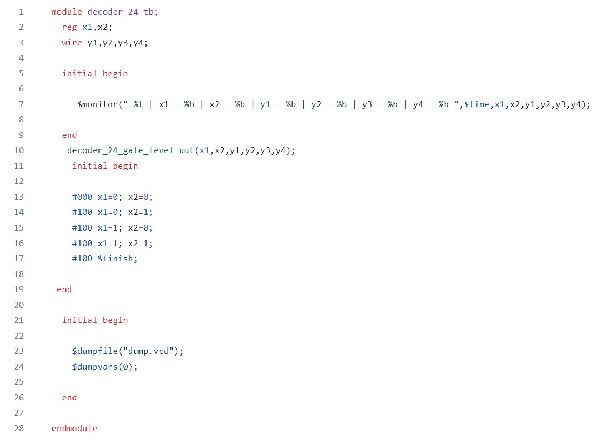

**OUTPUT:**

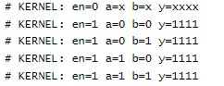

**Q.6) Design a 4x1 Mux using operators (use data flow).**

**CODE:**

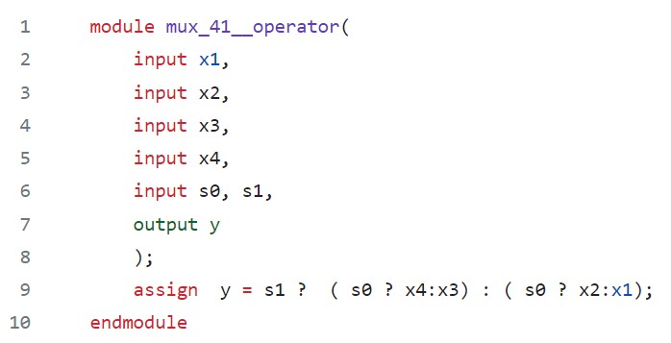

**TESTBENCH:**

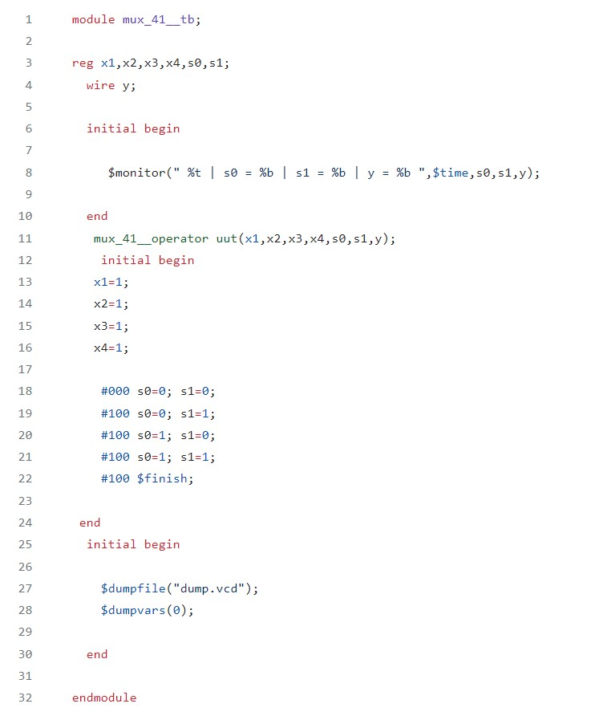

**OUTPUT:**

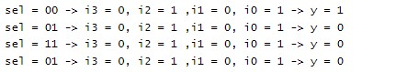

**Q.7) Design a Full adder using half adder.**

**CODE:**

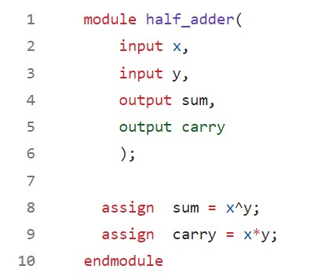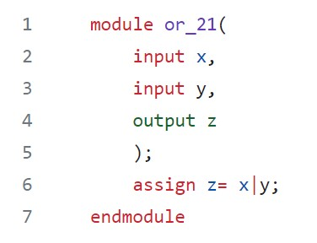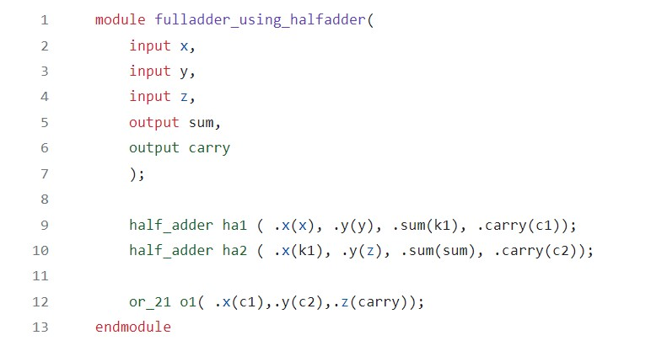

**TESTBENCH:**

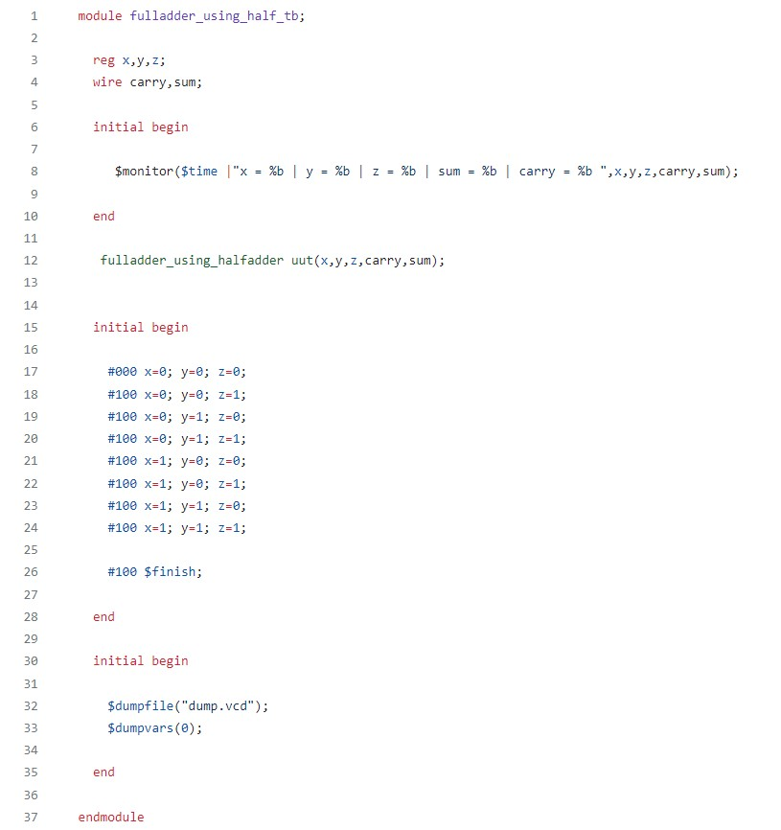

**OUTPUT:**

